
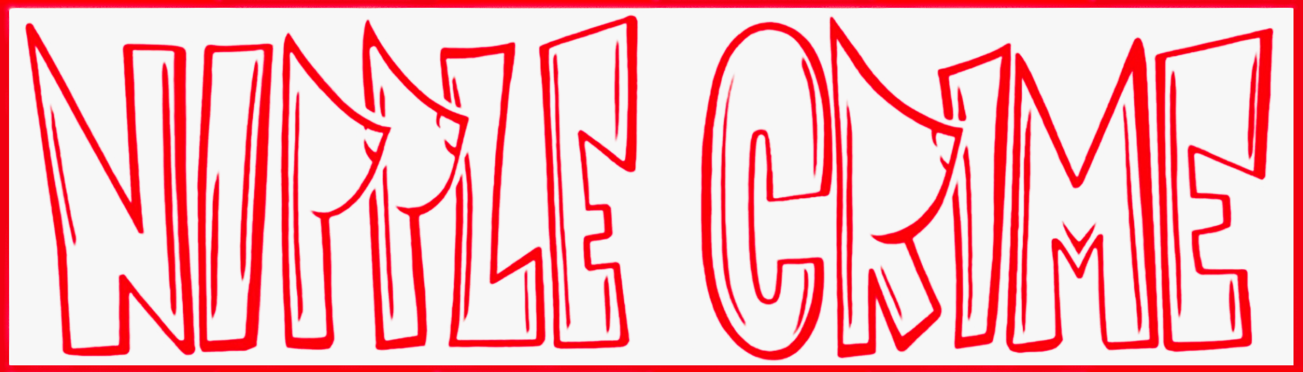

STANDARD OPERATING PROCEDURE
Stewards Sale (BMorg Ticket Allocation)

SOP Number | HR3 | Department | Human Resources
Version | 1.0 | Effective Date | 2026-05-13
Last Updated: 2026-05-13

1. Purpose
This SOP documents the annual process for managing Nipple Crime's Burning Man Stewards Sale ticket allocation. The Stewards Sale is a directed ticket sale run by the Burning Man Organization (BMorg) for placed theme camps and registered mutant vehicles. Camps receive a limited block of one-time-use ticket codes which are distributed to returning members in good standing. This SOP defines internal eligibility, distribution mechanics, and recordkeeping. See Tr4 for the related Mutant Vehicle Statement of Intent process.

2. Timeline
- Placement / MVSOI submitted: February (see Tr3, Tr4)
- Stewards Sale allocations announced by BMorg: second week of February
- Camp receives ticket codes from BMorg: late February (date set by BMorg each year)
- Internal eligibility list finalized by HR: within 5 business days of allocation announcement
- Codes distributed to members: within 3 business days of receipt from BMorg
- Member redemption window (BMorg portal): typically 7-10 days; exact window set by BMorg
- Unredeemed code reclamation: 48 hours before redemption window closes
- Set calendar reminders at each milestone — the window is tight and codes do not roll over

3. Roles & Responsibilities
The Stewards Sale is owned end-to-end by Human Resources. No camp funds move through this process — members purchase tickets directly from BMorg using personally-paid funds — so the Treasurer has no operational role here.

HUMAN RESOURCES (full ownership):
- Maintain the Returning Member roster and good-standing status year-round
- Serve as Nipple Crime's point of contact with BMorg for the Stewards Sale
- Receive the ticket code block from BMorg and confirm count matches the allocation
- Produce and finalize the internal eligibility list each Stewards Sale cycle
- Distribute codes to eligible members (see Section 5)
- Communicate eligibility, deadlines, and redemption instructions
- Track redemption status and reclaim/reassign unredeemed codes (see Section 6)
- File records per Section 7

PRESIDENT (oversight):
- Final approval on the eligibility list and any exceptions
- Resolve disputes; sign off on reclamations and reassignments

MEMBERS (individual responsibility):
- Pay BMorg directly for their ticket using the assigned code
- Confirm redemption to HR within 24 hours of purchase
- Carry full personal responsibility for their own ticket funds; the camp does not collect, hold, or refund ticket payments

4. Member Eligibility — Returning Members in Good Standing
Stewards Sale codes are distributed only to Returning Members in Good Standing. A member meets this standard if ALL of the following are true at the time the eligibility list is finalized:

- Camped with Nipple Crime in at least one of the two prior Burns
- Dues for the current Burn year are paid (or on a Treasurer-approved payment plan)
- Met or committed to the camp's minimum volunteer hours for the current year
- No outstanding incident, code-of-conduct, or LNT issues from prior Burns
- Confirmed 'Yes' on the current year's interest form (see Com3)

PRIORITY ORDER (when codes are fewer than eligible members):
- Active Board members and Leadership role holders
- Confirmed critical-crew leads (Build, Kitchen, Power, LNT, Medical, Safety)
- Returning members with 2+ prior Burns and dues paid in full
- Returning members with 1 prior Burn and dues paid in full
- All other Returning Members in Good Standing

Exceptions to eligibility (e.g., first-year leadership, hardship cases) require President approval and must be logged in the eligibility record.

5. Code Distribution Process
Members purchase tickets directly from BMorg using one-time-use codes issued to the camp. Nipple Crime does NOT collect ticket payments or purchase tickets on behalf of members.

- HR receives the code block from BMorg via email or BMorg portal
- HR confirms the code count matches the allocation
- HR confirms the finalized eligibility list with the President
- HR assigns one code per eligible member, in priority order, until codes are exhausted
- HR emails each member individually with:
- Their assigned code (do NOT post codes in Slack or any shared channel)
- The redemption deadline (date and time, with timezone)
- A direct link to the BMorg redemption portal
- A reminder that codes are one-time use and tied to the member's BMorg account
- Instructions to reply confirming redemption within 24 hours of purchase
- HR logs each code-to-member assignment in the Stewards Sale tracker
- Members redeem in the BMorg portal during the redemption window

SECURITY: Codes have monetary value. Treat them like cash.
- Never post codes in any Slack channel, public document, or group email
- Send codes only via direct 1:1 email to the assigned member
- If a code is leaked or compromised, HR notifies BMorg and the President immediately

6. Unredeemed Code Reclamation
Unused codes are forfeited at the end of the BMorg redemption window. To avoid waste:

- 72 hours before close: HR sends a reminder to any member who has not confirmed redemption
- 48 hours before close: HR reclaims any code where the member has not confirmed or responded
- Reclaimed codes are reassigned to the next eligible member on the priority list (Section 4)
- Reassignments follow the same 1:1 email process from Section 5
- All reclaim/reassign actions require President sign-off and are logged in the tracker

7. Record Keeping
Maintain the following each Stewards Sale cycle. Retain records for a minimum of 5 years.

- Eligibility list (final), with priority tier and exceptions noted
- Code-to-member assignment log (member name, email, code last 4, assignment date, redemption status)
- Member redemption confirmations (forwarded emails or screenshots)
- BMorg correspondence (allocation announcement, code block delivery, post-sale report)
- Reclamation/reassignment log with President approvals

File location: [Shared Drive > HR > Stewards Sale > YYYY]
Do NOT retain the full ticket codes themselves after the redemption window closes — store only last 4 digits for reconciliation.
Note: No financial records are produced by this process. Member ticket payments are personal transactions with BMorg and are not part of camp bookkeeping.

8. Contacts
- HR Officer (process owner, BMorg POC, code distribution): [TBD] — [email]
- President (approvals + exceptions): Reece Dassinger — reece@nipplecrime.org
- VP / SOP Owner: Chris Reddin — creddin1@hotmail.com
- BMorg Stewards Sale: tickets.burningman.org / tickets@burningman.org

9. Revision History
- v1.0 | 2026-05-13 | Initial draft | Chris Reddin

